Investigation into the Influence of Link Dimensional Errors on the Positioning Accuracy of a Four-Degree-of-Freedom SCARA Robot
Thuy Le-Thi-Thu,
Faculty of Mechanical Engineering, Thai Nguyen University of Technology, Thai Nguyen University, Thai Nguyen Province, Vietnam. Email: hanthuyngoc@tnut.edu.vn; phone number: 084 982 567 982

ABSTRACT
The SCARA (Selective Compliance Assembly Robot Arm) is a four-degree-of-freedom robot widely used in microchip assembly and placement processes, thanks to its high flexibility in the horizontal plane. The positioning accuracy of the robot's end-effector directly determines the quality of the assembled products. This paper presents a study evaluating the influence of link dimensional manufacturing errors on the positioning accuracy of the SCARA robot gripper. The mathematical relationship is established using the Denavit-Hartenberg (D-H) homogeneous transformation matrix method and total differentiation. Numerical simulation results in MATLAB indicate the error contribution level of each individual link to the final position error. This research provides an important database to help designers allocate manufacturing tolerances rationally and optimize robot production costs.
Keywords: SCARA robot; Manufacturing error; Tolerance; Kinematics; Positioning accuracy.
1. INTRODUCTION
In modern flexible manufacturing systems, the SCARA (Selective Compliance Assembly Robot Arm) configuration is a highly popular class of four-degree-of-freedom manipulators. This robot type is extensively applied in high-speed pick-and-place operations, product sorting, and electronic component assembly [1]. Characterized by a structure featuring three parallel-axis revolute joints and one vertically moving prismatic joint, the SCARA robot exhibits high rigidity along the vertical axis while maintaining exceptional flexibility within the horizontal plane [2]. For tasks involving microchip positioning or precision mechanical assembly, the positioning error of the end-effector serves as a core technical indicator. This parameter directly dictates the defect rate and overall quality of the entire production line [3].
However, in actual manufacturing, the geometric dimensions of robot links invariably deviate from their nominal designs. These variations stem from the limitations of machining capabilities and cumulative errors during mechanical assembly [4]. Numerous empirical studies have demonstrated that for newly commissioned manipulator systems, geometric errors account for over 70% of the total initial positioning error. This factor significantly outweighs non-geometric error sources, such as thermal deformation or elastic backlash [5]. Arbitrarily tightening the manufacturing tolerances of all links can enhance robot accuracy. However, this approach simultaneously causes production costs to grow exponentially, leading to economic inefficiency [6]. Conversely, excessively loosening tolerances will prevent the robot from satisfying specific technological requirements. Consequently, quantitatively evaluating the impact of individual link dimensional errors on end-effector positioning accuracy represents an optimization problem of high practical significance [7].
Driven by these requirements, research directions focused on analyzing the relationship between source errors and manipulator positioning reliability have attracted substantial academic interest. Regarding error modeling methodologies, Weill et al. [8] laid the foundation by establishing transformation matrix chains to evaluate end-effector deviations. To determine the influence weight of individual component parameters, Dao Duy Son and Abhary [9] successfully applied the Design of Experiments (DOE) method to rank the impact levels of the dimensional chain across the workspace. Furthermore, the trend of optimizing tolerance allocation - by coupling positioning accuracy objectives with machining cost constraints - has been aggressively pursued by Wu and Rao [10] using numerical search algorithms.
Although prior works have achieved significant milestones, solving error problems for high-degree-of-freedom configurations (such as 6DOF robots) frequently involves highly complex Jacobian matrix computations. This complexity hinders rapid implementation by design engineers on the factory floor. To simplify the model and enhance its practical applicability, this paper focuses on developing an analytical mathematical model based on the total differentiation method. This approach decouples and investigates the individual impact of link length errors on the positioning accuracy of a 4DOF SCARA robot. The simulation and computation processes are executed in MATLAB using common geometric parameter sets. The obtained results not only clarify the error contribution level of each distinct link but also provide an intuitive database. This information assists manufacturers in allocating tolerances rationally, thereby ensuring target accuracy while minimizing production costs.
2. THEORETICAL BACKGROUND AND RESEARCH METHODOLOGY
2.1. Kinematic Equations of the SCARA Robot
The investigated SCARA robot configuration consists of four degrees of freedom, including three revolute joints (q₁, q₂, q₄) and one prismatic joint (q₃). The coordinate systems of the robot links are established according to the Denavit-Hartenberg (D-H) convention (Figure 1).
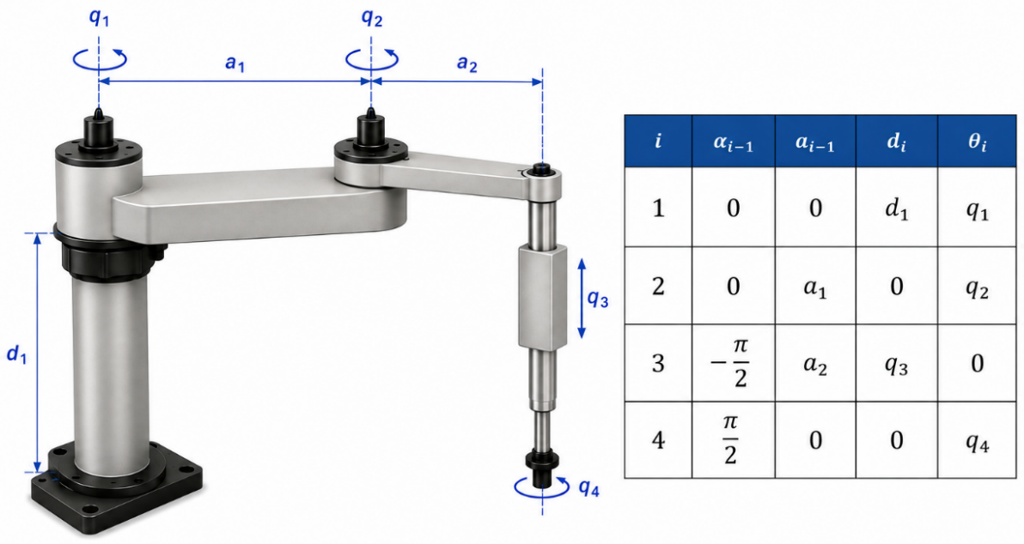
Figure 1: The 4DOF SCARA robot and its D-H kinematic parameter table.
The nominal geometric dimensions that determine the robot's position include:
- a₁: Length of link 1 (mm).
- a₂: Length of link 2 (mm).
- d₁: Height of the base supporting link 1 (mm).
The forward kinematic equations defining the end-effector position coordinates (P_{x}, P_{y}, P_{z}) as functions of the joint variables and link parameters are expressed as follows:
$$P_{x} = a_{1}cos(q_{1}) + a_{2}cos(q_{1} + q_{2})$$
$$P_{y} = a_{1}sin(q_{1}) + a_{2}sin(q_{1} + q_{2})$$
$$P_{z} = d_{1}- q_{3}$$
2.2. Mathematical Model of Positioning Error Induced by Link Dimensional Errors
When manufacturing errors occur during mechanical machining, the actual dimensions of the links deviate from their nominal values by corresponding tolerance amounts, denoted as δa₁, δa₂, δd₁.
By applying the total differential method to the system of forward kinematic equations, the relationship between the directional positioning errors (δP_{x}, δP_{y}, δP_{z}) and the link dimensional errors is established as follows:
$${δP}_{x} =\frac{∂P_{x}}{∂a_{1}}{δa}_{1} +\frac{∂P_{x}}{∂a_{2}}{δa}_{2}=\cos\left(q_{1}\right)δa_{1}+\cos\left(q_{1}+q_{2}\right)δa_{2}$$
$${δP}_{y} =\frac{∂P_{y}}{∂a_{1}}{δa}_{1} +\frac{∂P_{y}}{∂a_{2}}{δa}_{2}=\sin\left(q_{1}\right)δa_{1}+\sin\left(q_{1}+q_{2}\right)δa_{2}$$
$${δP}_{z} =\frac{∂P_{z}}{∂d_{1}}{δd}_{1}=δd_{1}$$

The cumulative positioning error at the end-effector (δR) is determined using the spatial geometric formula:
$$δR =\sqrt{{δP}_{x}^{2}+{δP}_{y}^{2}+{δP}_{z}^{2}}$$
To investigate the individual error contribution levels, this study isolates each link by setting its error to the maximum allowable value within the tolerance zone, while assuming the remaining links are ideal (with zero error).
3. SIMULATION COMPUTATION AND DISCUSSION
To provide a visual illustration, this study conducts an investigation on a commercial SCARA robot with nominal dimensional parameters similar to the Epson G3 series, specified as follows: a₁ = 250 mm; a₂ = 150 mm; d₁ = 300 mm.
The mechanical manufacturing accuracy grade is assumed according to the ISO IT11 standard. Accordingly, the maximum allowable manufacturing tolerance for each link is determined as follows:
- ${δa}_{1} =± 0.130 mm$
- ${δa}_{2} =± 0.090 mm$
- ${δd}_{1} =± 0.130 mm$
The investigation is carried out at a central operating point within the robot's workspace, with a specific joint configuration defined by: q₁ = 30⁰, q₂ = 45⁰, q₃ = 50 mm.
By utilizing the numerical computation tools within a specialized software (MATLAB), the individual impacts of each link error on the end-effector position deviation are detailed in Table 1 and visualized in Figure 2.
Table 1. End-effector position deviations induced by manufacturing errors of individual links.
Investigated Link with Error | Link Error Amount (mm) | δPx​ (mm) | δPy​ (mm) | δPz​ (mm) | Cumulative Position Error δR (mm)
Link 1 Length (a₁) | 0.130 | 0.1126 | 0.0650 | 0.0000 | 0.1300
Link 2 Length (a₂) | 0.090 | 0.0233 | 0.0869 | 0.0000 | 0.0900
Base Height (d₁) | 0.130 | 0.0000 | 0.0000 | 0.1300 | 0.1300

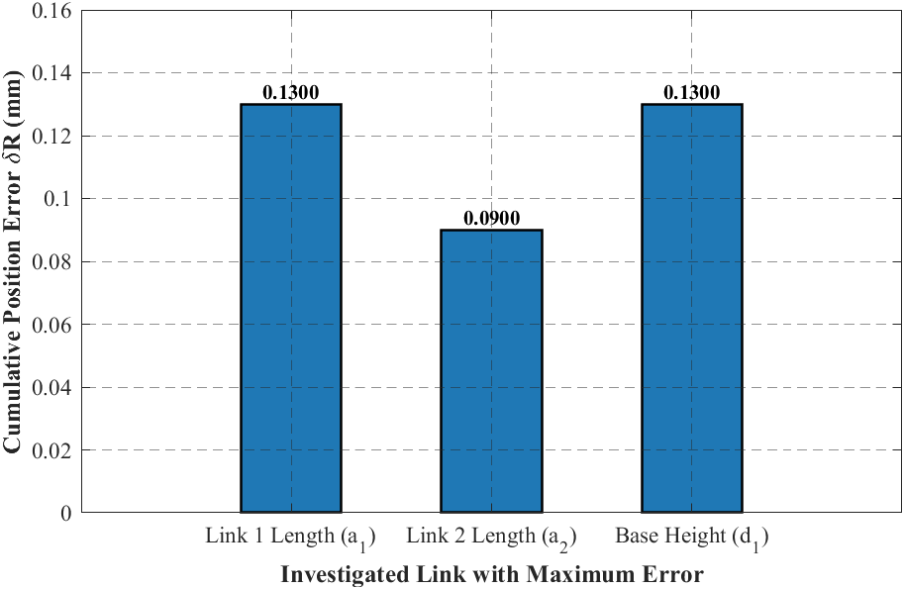
Figure 2. Comparison of cumulative positioning errors (δR) under the individual influence of each manufacturing error.
From the simulation results, the following observations can be made:
- Due to the kinematic characteristics of the SCARA robot, which feature a clear separation between the horizontal plane (X-Y) and the vertical axis (Z), the height error of the base supporting link (d₁) is fully transferred linearly (100%) into the vertical position error (δP_{z}).
- Within the horizontal plane of motion, the larger link length error (a₁ = 250 mm) generates a higher cumulative position deviation (δR = 0.1300 mm) compared to the smaller link (a₂).
- Synthesizing the dimensional chain reveals that the group of long dimensions determining the robot's reach possesses the highest linear influence weight on the final positioning accuracy of the end-effector.
4. CONCLUSIONS AND RECOMMENDATIONS
Based on the theoretical formulation and numerical simulation results for the four-degree-of-freedom SCARA robot, several core conclusions and future recommendations are summarized as follows.
Conclusions:
- This paper has successfully developed a differential mathematical model to determine the influence of link dimensional manufacturing errors on the positioning accuracy of the SCARA robot end-effector.
- The geometric errors of the primary links exhibit a substantial and direct impact on the positional deviation of the gripper. Specifically, links with larger nominal dimensions produce more severe adverse effects on the final positioning error.
- For the SCARA robot configuration, controlling and tightening the manufacturing tolerances of the base height (d₁) and the first link (a₁) must be prioritized to guarantee the required assembly accuracy. Conversely, the tolerance for the secondary link (a₂) can be relaxed to minimize machining costs without significantly compromising the overall system performance.
Recommendations and Future Work:
- To further advance this research direction, the authors plan to expand the analytical model by incorporating the simultaneous, coupled effects of joint angle errors (such as bearing clearances) and dynamic load variations. This extension aims to significantly enhance the practical fidelity and realism of the predictive model under real-world operating conditions.
5. ACKNOWLEDGMENTS
This work was supported by the Thai Nguyen University of Technology (TNUT), Thai Nguyen Province, Vietnam.
6. REFERENCES
[1] M P Groover. Automation, Production Systems, and Computer-Integrated Manufacturing. 5th ed. Pearson, 2009.
[2] J J Craig. Introduction to Robotics: Mechanics and Control. 4th ed. Pearson, 2018.
[3] Nguyễn Thiện Phúc. Robot công nghiệp [Industrial Robot]. Nhà xuất bản Khoa học và Kỹ thuật, Hà Nội, 2006 (in Vietnamese).
[4] M Vukobratovic and B Borovac. Accuracy of the robot positioning and orientation assessed via its manufacturing tolerances. Mechanism and Machine Theory.1995, vol. 30, no. 1, pp. 11–32.
[5] J Zhu and K Ting. Uncertainty analysis of planar and spatial robots with joint clearances. Mechanism and Machine Theory. 2000; vol. 35, pp. 1239–1256.
[6] P Huang, J Wang and L Wang. Tolerance design of industrial robots based on an improved genetic algorithm. Mechanism and Machine Theory. 2020; vol. 152, p. 103943.
[7] Thuy Le-Thi-Thu and Viet Khong-Van. Impact of Link Length Manufacturing Errors on the Positioning Accuracy of Industrial Robots. International Journal of Advanced Multidisciplinary Research and Studies. 2025; 5(2):1208-1213.
[8] R Weill and J Shani. Evaluation of robot positioning accuracy by kinematic error modeling. CIRP Annals. 1989; vol. 38, no. 1, pp. 503–506.
[9] S D Dao and K Abhary. Determination of the Significance of Tolerance Parameters on Robot Performance Using Taguchi’s Tolerance Design Experiment. Applied Mechanics and Materials. 2012; vol. 229, pp. 2100–2105.
[10] W Wu and S S Rao. Uncertainty analysis and allocation of joint tolerances in robot manipulators based on interval analysis. Reliability Engineering & System Safety. 2007; vol. 92, no. 1, pp. 54–64.

